Follow these 5 AI prompting rules to automate your expertise (and 10X your writing productivity)
Why AI won't steal your writing job (but AI writers will)

Nicolas Cole
May 28, 2025
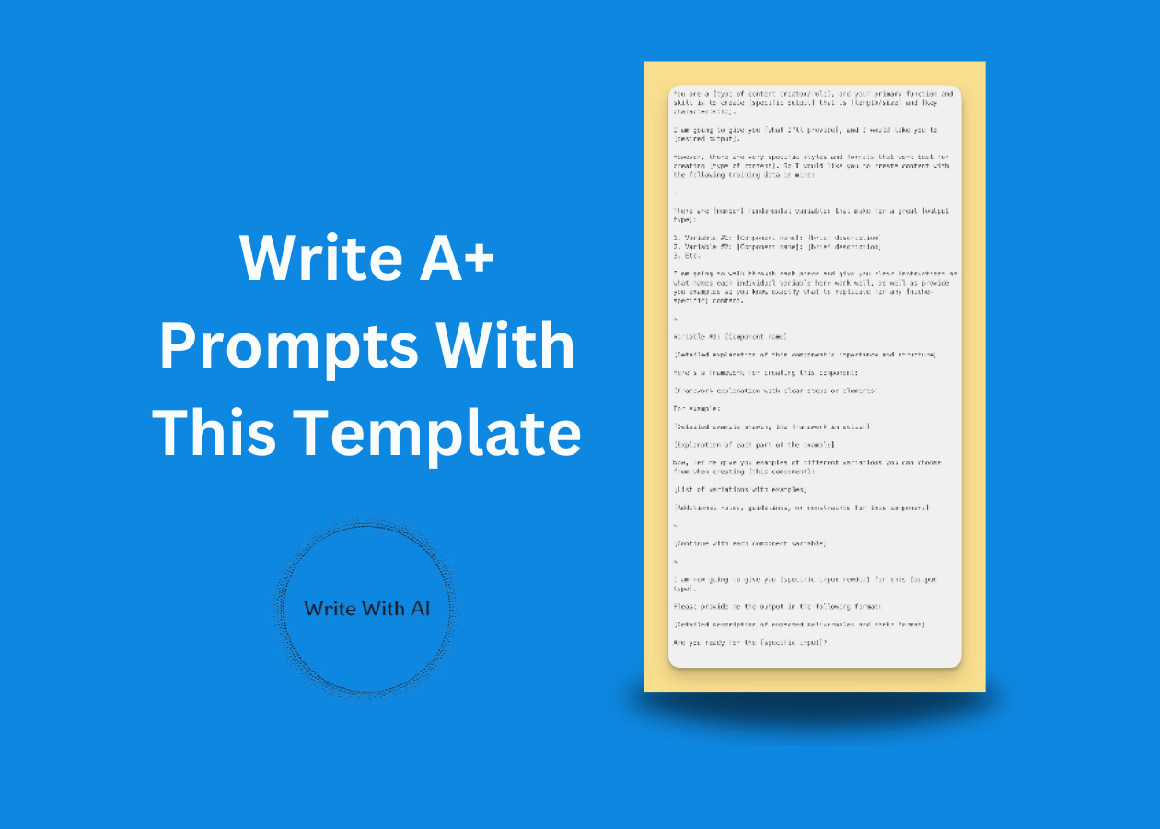

Every time I release anything about AI and writing, 80% of the comments say the same thing:
"Why bother building writing skills when AI will just steal my job?"
But after spending hundreds of hours with these tools, here’s what I’ve realized:
AI technology isn't replacing humans. Humans who understand the technology are replacing humans who don't. Just like graphic designers who learned Photoshop replaced those who insisted on drawing by hand. Think about it. When a client needs a newsletter written in 2 days instead of 2 weeks, which writer gets hired? The one who can deliver faster using AI, or the one who refuses to touch it?
Now here's what's ironic:
Legacy writers…the ones most afraid of AI stealing their jobs, are actually in the best position to leverage Claude, ChatGPT, or any other LLM.
Why?
Because they have 10+ years of experience writing in their niche.

The challenge for writers isn’t learning AI tech (anyone who knows how to send a text message can use ChatGPT).
The bottleneck is being able to articulate what you already know how to do.
That's like hiring an intern and saying "Do that thing I can't describe to you." How would they even start?
You can't automate something you can't explain.
So the real skill is translating your expertise into instructions AI can follow.
Here are the 5 rules that will help you do exactly that:

Rule #1: Frame your prompt with YOUR role and purpose statement before anything else.
When you jump straight into your prompt without setting context, you're essentially asking the AI to guess what you really want.
Think of this like hiring a new team member without explaining their role or your expectations. No matter how talented they are, they'll waste time figuring out what they should be doing instead of delivering results.
Always start your prompt with these two critical elements:
- Who you want the AI to be (the role)
- What specific output you need (the purpose)
For example, instead of "Write me a marketing email," try:
"You are an experienced SaaS Marketing Specialist. Create a product launch email for our new analytics dashboard that emphasizes time-saving features for busy executives."
Ask ChatGPT to take on your role.
If you're an email marketer, tell ChatGPT to be an email marketer. If you're a newsletter writer, make it a newsletter writer. Train AI to embody your persona and knowledge. Sure, you can have it adopt roles you're not familiar with to leverage expertise you don't have yet—but the real power comes from amplifying what you already know how to do.
This role-purpose framing immediately aligns the AI with your objectives and significantly improves the relevance of everything that follows.

Rule #2: Train AI on very specific formats.
The whole secret to writing effective prompts is to train technology on very specific formats.
You could also call it a style. It's a certain type of asset you are creating—like a Twitter thread, newsletter, or landing page. But it's not enough to say "write a LinkedIn post." You need to break the format down into its core attributes. This includes the sections you want in the output, the order those sections should appear in, and any specific formatting requirements (bold text, bullet points, etc.).
So, the first thing you do is say, "Here is the specific format I want to use" and then you break it down.
For example, let’s say you want to write a newsletter, you could break it down like this:
- Subject Line
- Preview Text
- Greeting
- Introduction
- Subheaders
- Section Content
- CTA
This explicit output specification ensures you get exactly what you need in a ready-to-use format, minimizing your editing time.
Simply naming the format and attributes puts you in the top 1% of prompt writers, but you can do even better by following the next rule. In fact, I believe the next rule is the most important rule in this list.

Rule #3: Give objective directions, not subjective ones.
The mistake I see writers make when they approach AI is they give what I like to call subjective directions.
"Write really great content that will engage my audience and make them want to buy my product."
This is subjective because what you think is "great content" and what AI thinks is "great content" are probably two totally different things. AI doesn’t work well with subjectivity because it’s using billions of different data points and trying to make sense of what you want.
On the other hand, objective directions are black and white. They either happened or they didn't.
So for every attribute in your prompt, include objective instructions on how to execute it.
Example:
“Open with 1 single sentence.
Choose one of the following openers:
Ask a thought-provoking question.
Open with a strong, declarative sentence.
Reference a meaningful moment in time (date, day, time, moment, etc.).
Present a vulnerable statement.
Offer a controversial opinion; and/or share a unique insight.”
You can point to the output and prove ChatGPT either wrote a single-sentence opener using one of the 6 proven types or it didn’t.

Rule #4: Provide examples that execute the rules perfectly.
Where people go wrong with examples is they throw a bunch of information into their chat window and expect AI to “figure it out.”
This is not what yields the best output.
What yields the best output is you saying very specifically "this is the format I would like you to write. These are the rules of the format. These are the attributes that make this format work well. And here are examples that execute these rules and these attributes to a T."

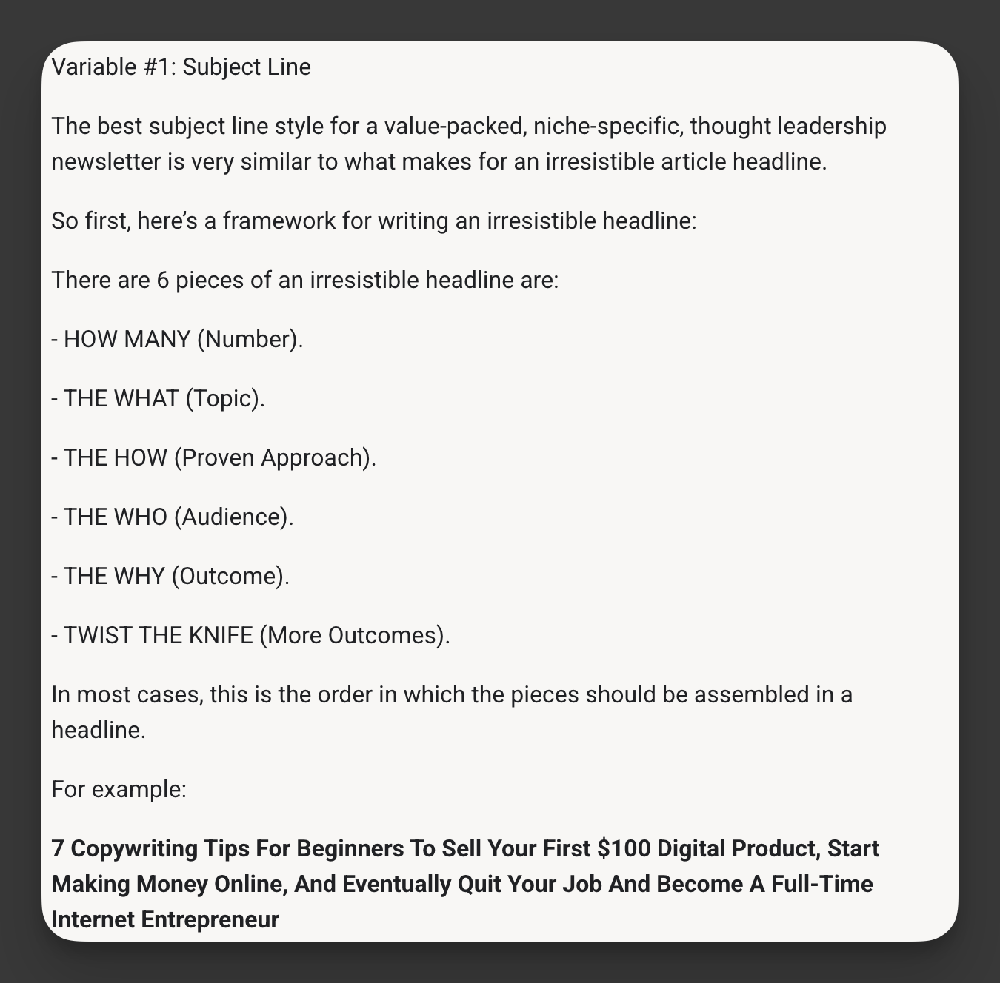

The examples that you give have to literally, as close as possible, mirror the rules that you just laid out. The more similar the examples are to the rules of an individual format, the more likely you are to get an effective output.

Rule #5: Use visual organization to create clear section boundaries that guide the AI's attention.
The visual structure of your prompt significantly impacts how well the AI processes your instructions.
Most people write prompts as dense walls of text with minimal visual organization. This is like handing someone a map with no labels, colors, or legends—technically all the information is there, but it's nearly impossible to navigate effectively.
Create prominent visual boundaries between major sections using:
- Bold section headers (## Main Concept)
- Divider symbols (~~~)
- Numbered sequences for steps
- Strategic whitespace between sections
For example:
## TONE GUIDELINES
Make the copy conversational but authoritative.

Use second-person perspective and contractions.

~

## STRUCTURE REQUIREMENTS
1. Begin with a question that highlights the pain point
2. Follow with 3 bullet points describing consequences of the problem
3. Introduce the solution with a transition paragraph

This visual scaffolding helps the AI navigate your prompt like a well-designed website rather than a cluttered document, making it much easier to follow your instructions.
That’s it.
When you're writing prompts, you need:
- A defined role
- A specific format to follow
- A set of rules to execute the format
- A reinforcing example for those specific rules
- And a neatly organized (readable) set of instructions

Here’s your ready-to-use template for structuring prompts that deliver A+ results every time:
Use this template whenever you want to train AI on a specific type of content you create regularly—like newsletters, social posts, sales pages, or blog articles.
Simply fill in the bracketed placeholders with your specific requirements, then save it as a reusable prompt you can modify for different projects.
The key is to be as detailed as possible in each section, especially the examples and formatting rules.
Here’s the template:
You are a [type of content creator/role], and your primary function and skill is to create [specific output] that is [length/size] and [key characteristic].

I am going to give you [what I'll provide], and I would like you to [desired output].

However, there are very specific styles and formats that work best for creating [type of content]. So I would like you to create content with the following training data in mind:

~

There are [number] fundamental variables that make for a great [output type]:

1. Variable #1: [Component name]: [brief description]
2. Variable #2: [Component name]: [brief description]
3. Etc.

I am going to walk through each piece and give you clear instructions on what makes each individual variable here work well, as well as provide you examples so you know exactly what to replicate for any [niche-specific] content.

~

Variable #1: [Component name]

[Detailed explanation of this component's importance and structure]

Here's a framework for creating this component:

[Framework explanation with clear steps or elements]

For example:

[Detailed example showing the framework in action]

[Explanation of each part of the example]

Now, let me give you examples of different variations you can choose from when creating [this component]:

[List of variations with examples]

[Additional rules, guidelines, or constraints for this component]

~

[Continue with each component variable]

~

I am now going to give you [specific input needed] for this [output type].

Please provide me the output in the following format:

[Detailed description of expected deliverables and their format]

Are you ready for the [specific input]?

Here’s why this template works:
- It starts with a clear role and purpose statement
- It builds information in layers from general to specific
- It groups all related concepts together
- It follows a logical creation sequence
- It places examples right after instructions
- It uses visual dividers to create clear boundaries
- It ends with a specific output format request
By implementing these 5 prompt structuring rules and using this proven template, you'll transform your AI interactions from frustrating time-wasters into productivity multipliers—allowing you to delegate 80% of the actual work, dramatically reduce editing time, and maintain complete creative control over the final output.

